**Finite State Machine assignments**

Mandatory

1. Refer the FSM code to search for a given pattern in input text in file finite_state_machine_regexp.c. Currently it does not work as expected. Fix the issues. Also modify the code to receive input string and search pattern from user.

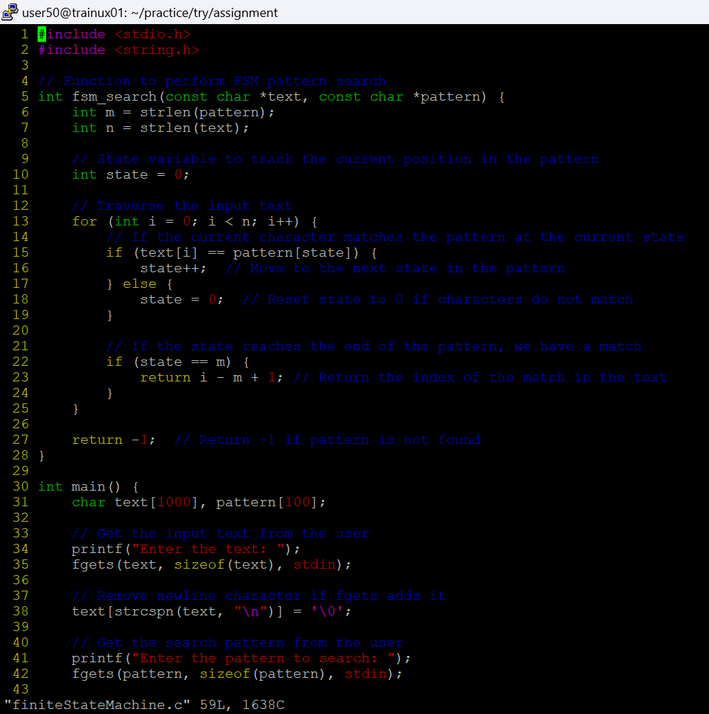

1. In state_machine_example1.c, complete the sections marked with TBD.

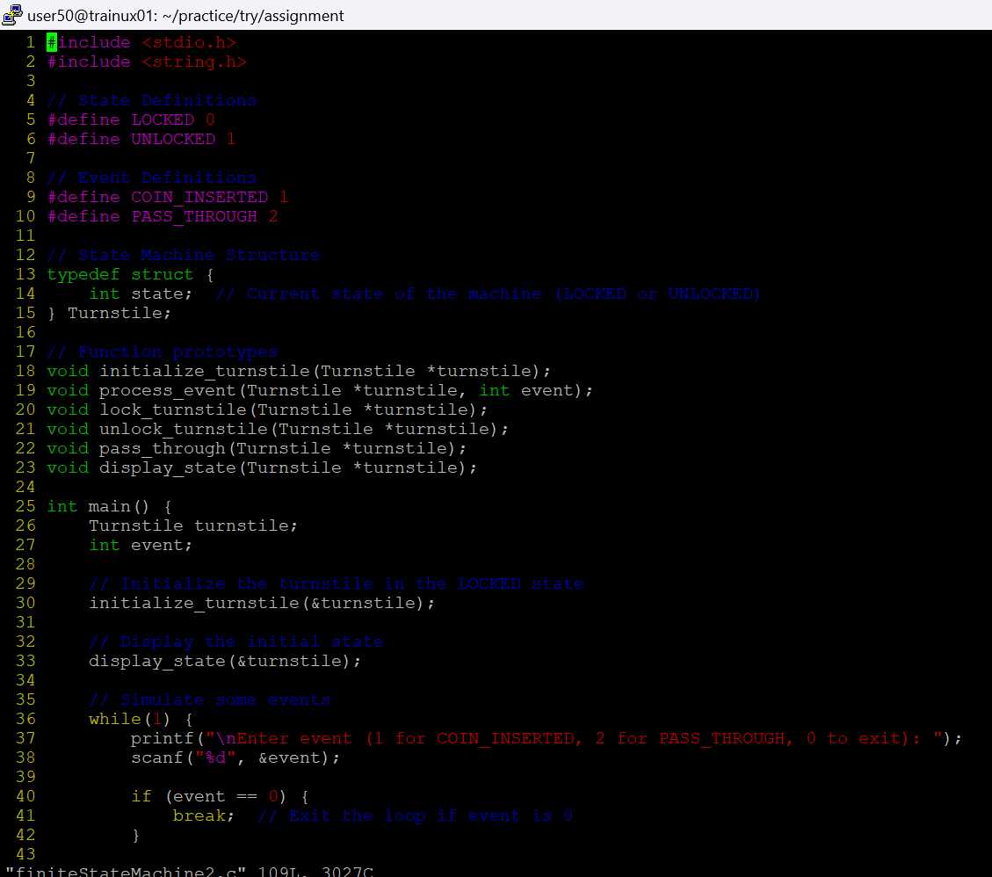

3. Implement a state machine as per given actions and state transitions below. Draw the complete state transition table.

Input Event as a character input Current State Action to perform Next State on action success

‘1’ S0 Prompt, read a string and store in heap S1

‘2’ S1 Prompt, read a search string, search for occurrent of this in earlier stored string, if found display message as “Sub string found” else “Sub string not found” S2

‘3’ S2 Free the memory allocated S0

Any other character X Display “Invalid character, enter 1 or 2 or 3” No state change



